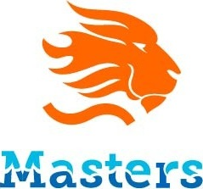
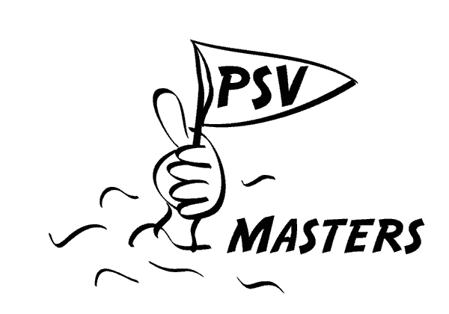
Masters Swimming Netherlands

mastersinschrijvingen@mastersprint.nl

Subscription Form Dutch Masters Club Meet
Competition: | NMCM 2025 | Date: | September 13th 2025 |  | Location: | Eindhoven
Club name |  |  | Contact person
 |  |  | Telephone number
 |  |  | E-mail:

Buffets
Officials | Participants |  | Extra (coach, partner, children) | TOTAL amount of buffets
Remarks, vegetarian or dietary requirements

Official(s)
First name | Last name | City | E-mail | Level | Buffet (yes / no)

Participants
Team 1 | Name | Buffet (yes / no)
1
2
3
4
5
6
7
8
9
10
11
12
13

Record application
License | Name Swimmer / relay team | Event | Entry Time | Current Record

Note: Form can be customized as needed

